Region 6 Network of Care and Prevention
Meeting Agenda
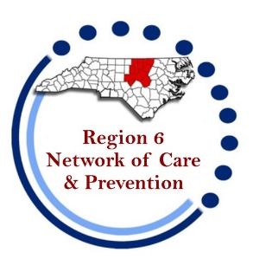
July 31, 2025 at 1:30pm
Location: Virtual via Teams

Welcome/Introductions/Housekeeping

Open Comment
Care Updates (Hailey Stout)
- Contracts/Budget
- Schedule Budget Follow up meeting
- Fee For Service (FFS) - Updates
HOPWA/Housing updates
- RW Housing (ACRA, CAARE, and TEC)
- City of Durham HOPWA – Durham, Chatham, Granville, Orange, and Person Counties
- Duke Partners in Caring HOPWA – Lee, Vance, and Warren Counties
- Wake HOPWA – Franklin, Johnston, and Wake Counties
Prevention Updates -

RQI –

State Updates –

“No one can whistle a symphony; it takes an orchestra...”

Open Comment

Upcoming Meetings: (Last Thursday of odd numbered months except November at 1:30om):
- August 28, 2025 (RW Budget)
- September 25, 2025 (in-person at Wake County Health Department 10 Sunnybrook Rd. Raleigh)
- November 20, 2025 (Held one week earlier due to Thanksgiving holiday)

