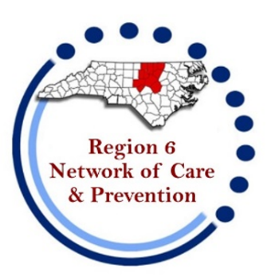


Region 6 Network of Care and Prevention
Meeting Agenda
November 19 at 1:30pm
Location: Virtual via Microsoft Teams

Welcome/Introductions/Housekeeping

Open Comment

CommWell Health

World AIDS Day – Updates from the Network

Care Updates – Hailey Stout
- Fee For Service

HOPWA/Housing updates
- SRO Housing
- City of Durham HOPWA – Durham, Chatham, Granville, Orange, and Person Counties
- Duke Partners in Caring HOPWA – Lee, Vance, and Warren Counties
- Wake HOPWA – Franklin, Johnston, and Wake Counties
Prevention Updates – Chris Mack

RQI Updates – Individual Agencies

NC EtE – Duke Partners in Caring

Upcoming presenters –
- November – WCHS - ITTS

State Updates

Next year’s meetings dates and times

“No one can whistle a symphony; it takes an orchestra...”

Open Comment/ Close of regular meeting

